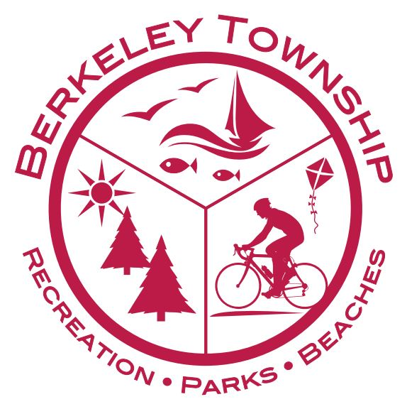
Debbi Winogracki Recreation Director

Berkeley Township
Exercise Programs
Classes are held at the Recreation Center
Berkeley Township Recreation
630 Atlantic City Boulevard (Rt. 9)
Bayville, NJ 08721

Exercise Classes: $25.00 for 6 classes

Zumba: Mondays at 6:00 pm Chair Yoga: Tuesdays at 9:00 am Beginner Yoga: Tuesdays at 6:30 pm
Tabata (Interval): Tuesdays at 5:30 pm ABC’s of Fitness: Wednesdays at 11:15 am
POUND®- Wednesdays at 5:30 pm Vinyasa Yoga: Thursdays 5:30 pm
Self-Defense: Every other Tuesday at 1 pm, beginning 9/17-12/3

Make checks payable to Berkeley Township, or pay online at www.BTREC.org
Any questions please call 732-269-4456. Classes may be subject to cancellation

Name _______________________________________________________________________________________
Address______________________________________________________________________________________
Phone _______________________________________________________________________________________
Emergency Phone #_____________________________________________________________________________
Email ________________________________________________________________________________________
Please list any special health concerns that might limit or affect participation in activity:

Zumba Chair Yoga Beginner Yoga Vinyasa Yoga
Tabata (Interval) ABC’s of Fitness Pound Self-defense

Session #4 _________ Amount enclosed: ___________
Agreement to participate: I hereby give my approval for myself and/or child(ren) to participate in the activities associated with this program. I assume all risks and hazards incidental to such participation, including transportation to these activities and do hereby waive, release, absolve, indemnify and agree to hold harmless Berkeley Township and all of its employees, participants, etc. whether the result of negligence or any other cause.
Photo Release: Berkeley Township Recreation has my permission to use my or my child’s photograph publically to promote the program. I understand that the images may be used in print publications, online publications, presentations, websites and social media. I also understand that no royalty, fee or other compensation shall become payable to me by reason of such use.
Name (Please print):______________________________________________________________________________

Signature Date

